FOR IMMEDIATE RELEASE

CITY PARKS FOUNDATION AND PARTNERSHIPS FOR PARKS ANNOUNCE $350,000 IN GRANTS FOR 57 GRASSROOTS COMMUNITY GROUPS
VOLUNTEERING IN PARKS AND OPEN SPACES ACROSS NYC

NYC GREEN FUND GRASSROOTS GRANTS WILL PROVIDE FUNDING TO TACKLE ENVIRONMENTAL AND SOCIAL ISSUES WITH COMMUNITY-LED SOLUTIONS

As funding to address equity, environmental justice, and climate change is slashed, New York City’s philanthropic community steps up to support grassroots volunteers in their efforts to care for and activate urban green space through the NYC Green Fund

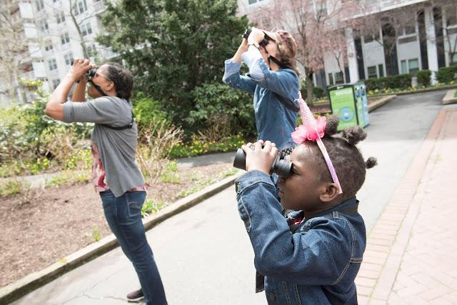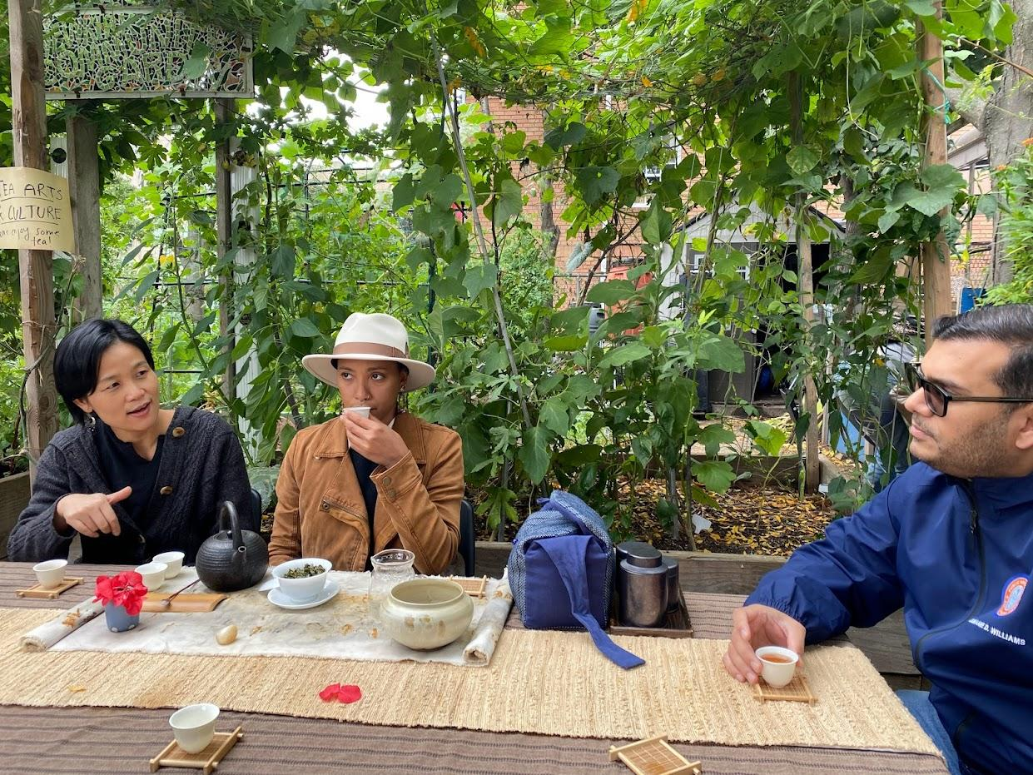
Nov 3, 2025 -- New York, NY -- City Parks Foundation and Partnerships for Parks today announced the recipients of the fall 2025 NYC Green Fund Grassroots grant program. Fifty-seven community groups from across the city, particularly in areas most vulnerable to environmental harms, will receive a total of $350,000 through the NYC Green Fund. The NYC Green Fund is a pooled grant program founded by private sector funders and philanthropists during the COVID-19 pandemic which has expanded into a long-term campaign due to high demand and high need.
The NYC Green Fund provides vital financial support for community groups sustaining local parks, many of whom are from Environmental Justice Areas — burdened with disproportionate environmental hazards due to historic and systemic inequities — neighborhoods with less access to green space, BIPOC communities, immigrant communities, communities with higher-than-average poverty levels, and other marginalized populations. Without this support, the future of these grassroots groups is precarious as funding for organizations addressing inequity, environmental injustice, and the climate crisis is under threat.
“We are thrilled to announce another round of funding from the NYC Green Fund to support our community partners across the city,” said Sabina Saragoussi, director of Partnerships for Parks. “This support is crucial for local community groups doing on-the-ground projects in neighborhood parks, sustaining and activating these parks for all of us to enjoy. Without this funding, much of this programming literally could not happen, so we are beyond excited to support our partners and our city in this concrete way.”
“The NYC Green Fund is a lifeline for the grassroots, volunteer groups who sustain parks and open spaces in our city,” said Heather Lubov, executive director of City Parks Foundation. “As we face draconian cuts in federal funding to public services, private funding from sources like the Green Fund are becoming more and more critical. We thank our funders for meeting the moment to ensure our public spaces are clean, green, and well-maintained.”
“A beautiful, accessible public park is not a luxury -- it’s a necessity for individual and community wellness,” said NYC Parks Commissioner Iris Rodriguez-Rosa. “We are grateful to the many grassroots organizations caring for and activating our greenspaces across the five boroughs. Thanks to this funding from the NYC Green Fund, these groups can further their work stewarding these critical public resources, particularly in neighborhoods that have experienced historic disinvestment. We congratulate them on their vital engagement for our communities, helping create a city that is greener, safer, and healthier.”
For decades, grassroots community groups across the city — many in underserved areas — have provided critical care and programming for local open spaces, fighting disinvestment and disrepair with grassroots efforts since the fiscal crisis of the 1970s. These groups rely on outside funding and support to survive and New Yorkers rely on these groups to sustain the green spaces necessary for a healthy and vibrant city.
The current round of the NYC Green Fund Grassroots grant program will provide grants ranging from $2,000 to $23,000 to support stewardship and activation of local parks and open spaces across the city with live arts and culture, environmental action, tree canopy expansion, youth development, and health and wellness programming. The Grassroots grants program prioritizes support for Environmental Justice Areas, majority BIPOC-led community groups, and groups with budgets under $50,000; supporting communities that experience historic and ongoing disparities including systemic racism and disinvestment.
The vision of the NYC Green Fund is to create a resilient and equitable NYC parks ecosystem for the benefit of all New Yorkers. The Fund is administered by City Parks Foundation with the grassroots grants program managed by Partnerships for Parks (PfP), a joint program of City Parks Foundation and the New York City Department of Parks & Recreation (NYC Parks). This year marks the 30th anniversary of PfP, the largest community engagement program for local parks in NYC. PfP has been bringing New Yorkers together across neighborhoods, backgrounds, and sectors to help local green spaces thrive since 1995.
The funded projects address environmental and social crises with inspired, community-led responses including upcycling hazardous waste, creating free youth programming in citizen science and robotics, developing programming for people of all abilities, deterring illegal dumping with community events, reaching non-English speaking communities with a bilingual musical, mitigating Hudson River pollution with local kayakers, and expanding the urban tree canopy with street tree planting and care.
Grantee project highlights:
- Jackson Heights Beautification Group from Queens will plant trees, install tree guards, expand tree beds, conduct ongoing tree care, and plant streetside pollinator gardens throughout Jackson Heights.
- NYC Mushroom Network will transform urban wood waste through mushroom inoculation workshops at popular NYC events, such as Mulchfest.
- Sadhana: Coalition of Progressive Hindus of Queens will clean Jamaica Bay of discarded religious offerings and repurpose these sacred, but environmentally hazardous objects, through youth-led art.
- Local Nature Lab from Manhattan will introduce girls aged 8-15 to birding and citizen science through environmental and arts-based educational programs.
- Bronx Special Kids will provide garden-based robotics classes to children with developmental disabilities.
- Maker Park Radio on Staten Island will organize over a dozen events and build critical infrastructure in Maker Park to deter illegal dumping and improve accessibility.
- Frog and Peach Theatre Company from Brooklyn will bring their signature, all-ages bilingual musical variety show TINKERBELL LIVE to six community gardens across the city.
- Manhattan Community Boathouse will develop regular on-water clean ups in the Hudson River, taking advantage of a robust existing community of kayakers to support this new stewardship initiative.
- Tea Arts and Culture will support 26 community leaders in organizing 35 free, accessible, intergenerational events across the five boroughs through the Community Engagement Tea program. In their first year of funding, they were able to engage over 200 residents through ten events which offered a space for attendees to slow down, engage in meaningful conversations, explore new learning experiences, and build connections through the art of tea.
Full list of Spring 2025 NYC Green Fund Grassroots grant recipients

The Bronx
At the Root Garden and Gallery
Bronx Special Kids
Bronx Sunshine Garden
Dominican Vitilla League in the USA (LIVIDOUSA)
Eastchester Road Community Garden
Godmother Productions
Green Patch on Walton
La Tribu del Juey Sambuco (The Sambuco Tribe)**
Sedgwick Park Friends and Neighborhood Group* **
Synergi Urban Garden 2.0

Brooklyn
Arts & Democracy, Inc.**
Brooklyn FAM: Festival of Arts and Music Inc.**
Casa Cultural**
Flutura Effect*
Friends of Fraser Square Park
Friends of Jackie Robinson Park Playground**
Frog & Peach Theatre Company
HomeGrown Parks Volunteers
Parachute Literary Arts**
Smith Street Stage Incorporated
South Midwood Pollinators, Inc.*
STooPS Art & Community**
The Circle Keepers
The Flossy Organization
United Cultural Association

Manhattan
200s West 109th Street Block Association*
City Hall Park Conservancy
Earth Celebrations Inc
First Touch
Friends of Corlears Hook Park
Friends of Peck Slip Park**
Garden of LOVE
Harlem Dance Club
Harlem Rose Garden
JumpShots Over GunShots**
Life Frames Inc.: A Living Library Think Park & Gardens* **
Local Nature Lab
Manhattan Community Boathouse
Mi Salsa Dura Baile
Project Harmony, Inc
Sixth Street & Avenue B Community Garden**
The Loisaida Foundry inc
West 123rd St. Community Garden**

Queens
Friends of Alley Pond Park**
Friends of MacDonald Park
Friends of Triboro G
Jackson Heights Beautification Group* **
Kissena Synergy Velodrome Friends Group*
Queensboro Dance Festival**
Sadhana: Coalition of Progressive Hindus

Staten Island
Friends of Corporal Thompson Park*
Friends of Mahoney Playground**
Maker Park Radio**
Pirate Park Families
Staten Island Therapeutic Gardens

Multi-Borough
NYC Mushroom Network*
Tea Arts & Culture**

*These grantees are helping to sustain and expand the tree canopy thanks in part to the NYC Green Fund’s Urban Forest Grants, brought to you by Con Edison.
**These grantees are receiving second-year funding.

Generous private support for the NYC Green Fund is provided by The Leona M. and Harry B. Helmsley Charitable Trust, Freedom Together Foundation, The Thompson Family Foundation, Essex Avenue Foundation, Con Edison, Leon Levy Foundation, Booth Ferris Foundation, The Charles H. Revson Foundation, The New York Community Trust, Altman Foundation, The Monarch Foundation, Albert Giving Fund, Treebed LLC, and Klein Family Foundation. The NYC Green Fund's Urban Forest Grants are brought to you by Con Edison. Additional support provided by Treebed LLC. For more information on the NYC Green Fund, visit cityparksfoundation.org/nycgreenfund.

About the NYC Green Fund Grassroots grant program
The NYC Green Fund Grassroots grant program is intended to advance the viability of grassroots initiatives across parks and open spaces in all five boroughs and to foster a resilient network of equitable public green spaces. The NYC Green Fund Grassroots grant program provides support for a range of programming areas including open space stewardship, tree canopy expansion, environmental action, organizational development, health and wellness, youth development, and arts and culture. With direct funding and technical assistance, diverse community groups receive support in their work to activate and enrich parks and open spaces across NYC. To contribute to the NYC Green Fund donate now or contact greenfundgrassroots@cityparksfoundation.org for more information.

About City Parks Foundation
At City Parks Foundation, we are dedicated to invigorating and transforming parks into dynamic, vibrant centers of urban life through sports, arts, community building and
education programs for all New Yorkers. Our programs -- located in more than 350 parks, recreation centers and public schools across New York City -- reach over 285,000 people each year. Our ethos is simple: thriving parks mean thriving communities.

About Partnerships for Parks
Partnerships for Parks is a unique public-private partnership between City Parks Foundation and NYC Parks that supports and champions neighborhood volunteers to advocate and care for neighborhood parks and green spaces. We equip people, organizations, and government with the skills, tools, and resources to ensure these spaces are dynamic community assets. More information about Partnerships for Parks is available at partnershipsforparks.org.

For information contact:
Tomasia Kastner, communications manager, Partnerships for Parks tomasia.kastner@parks.nyc.gov

###

